Tableau Project Solutions

XYZ company employee performance data needs to look back to its historical performance and business cycle in a way that will provide some meaningful information to take the strategic and informed decision for its expansion. The management of XYZ wants to outsource this task, to analyze the trend, pattern, forecast, and analysis, of the performance of account types.

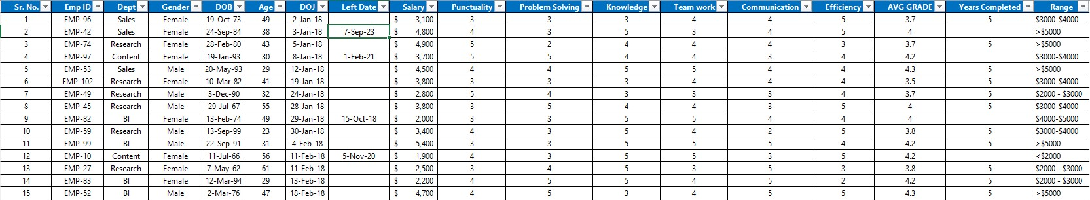

XYZ Employee Performance Year - 2023

**Visual Insights**

**Q1** Create number cards with the following information: total employees, average age, employed >=3 Years, hired in last 6 months, and left in the last 6 months.



***Step 1****: The age field drags into the (Text Cards)*.

***Step 2****: Open the drop-down of (Age) and select Measures then Average*

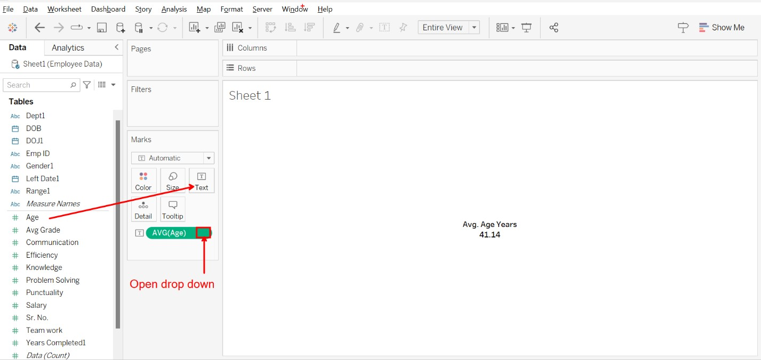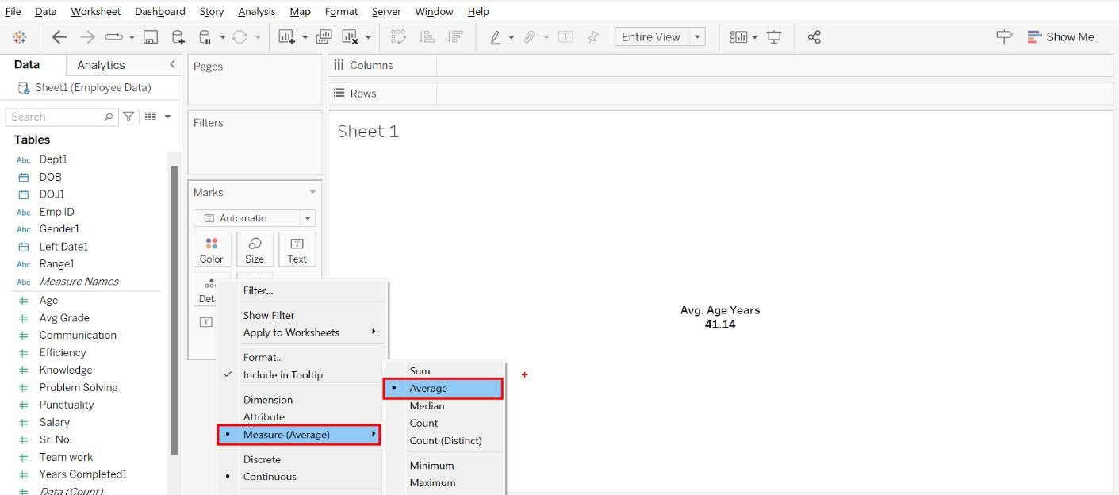

Create cards for hire in the last 6 months

***Step 1****: Drag the DOJ field into the filters*

***Step 2****: Drag Emp ID into the Text cards*

***Step 3****: Open the drop-down of the DOJ field (Filters)*

***Step 4****: Select Relative Date, Step 5: Month, Step 6: Previous Month, Step 7: Last (6), Step 8: Ok*

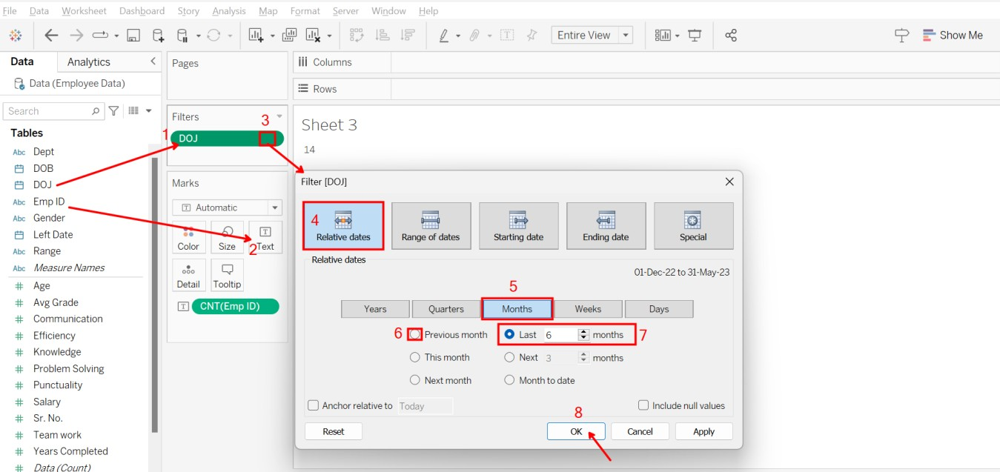

Create cards for Left in the last 6 months

***Step 1***: Drag the Left Date into the Filters

***Step 2***: Drag the Emp ID into the Text (Cards)

***Step 3***: Open the Drop-Down of the Left Date (Filters)

***Step 4***: Select Relative dates, Step 5: Month, Step 6: Previous Month, Step 7: Last 6 months, Step 8: Ok button

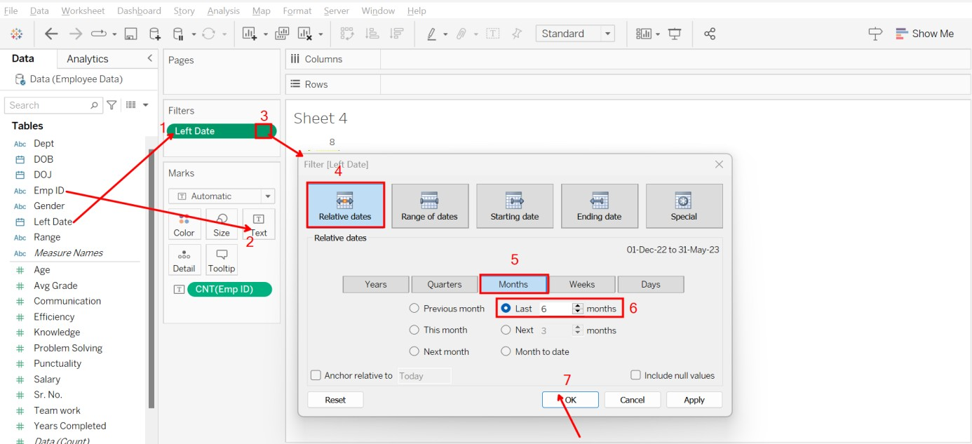

1. **2** Create one table for Department wise Gender Counts

**Like**

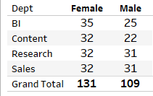

Step 1: Drag the field Gender into the Column area. Step 2: Drag the field Dept into the Row area

Step 3: Drag the field Emp ID into the Text Cards then open the drop-down and select measures and count

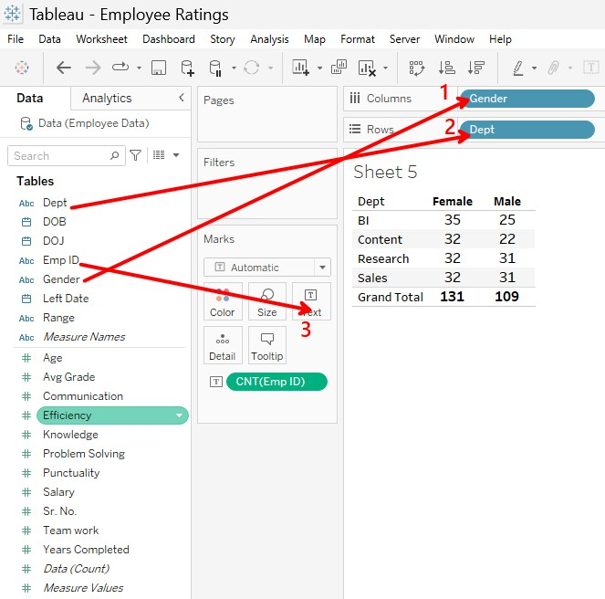

* 1. Make a bar graph showing the number of employees by salary range.

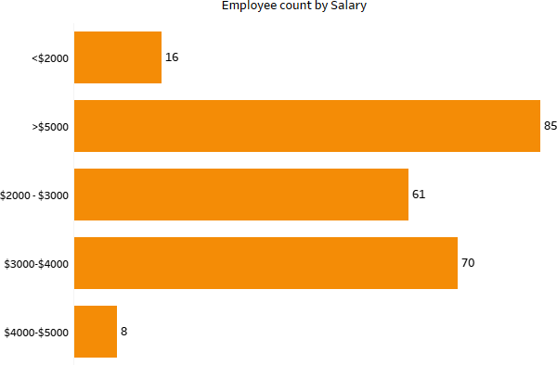

Like:

***Step 1****: Drag the Emp ID field into the Column area*

***Step 2****: Drag the Range field into the row area*

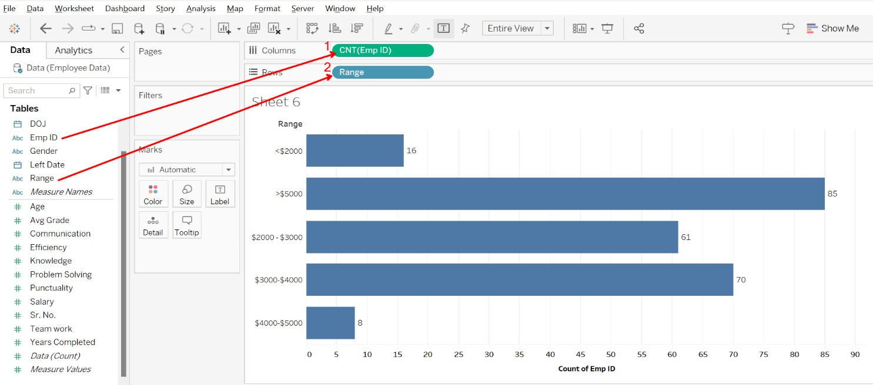

* 1. 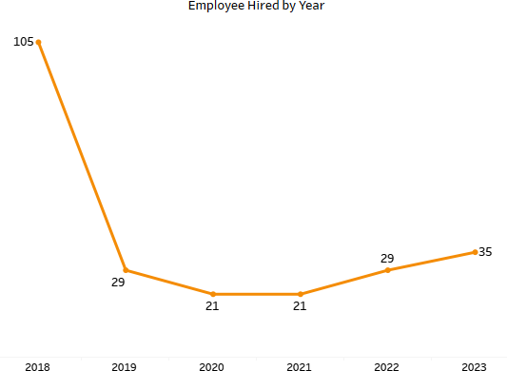Make a line graph showing the hiring of employees by year.

Like:

***Step 1***: *Drag the DOJ field into the column area*

***Step 2****: Drag the Emp ID field into the row area.*

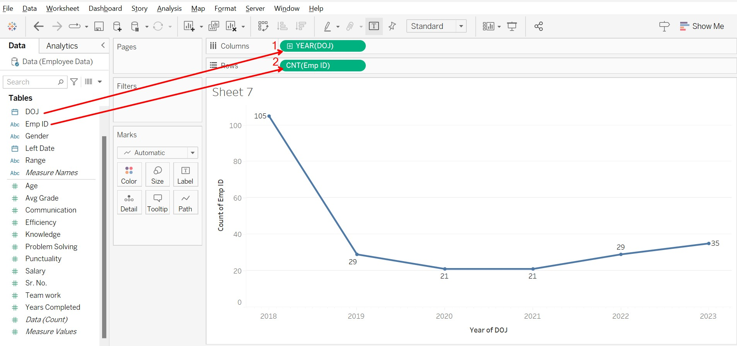

* 1. For employee ratings, make a column chart.

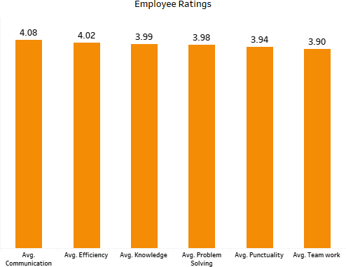

Like:

***Step 1:*** *Drag the Dept field into the Filters*

***Step 2:*** *Drag the Field of “Communication” into the label (Marks cards)*

***Step 3:*** *Drag the field “Efficiency” into the label (Marks cards)*

***Step 4:*** *Drag the field “Knowledge” into the label (Marks cards)*

***Step 5:*** *Drag the field “Problem-Solving” into the label (Marks cards)*

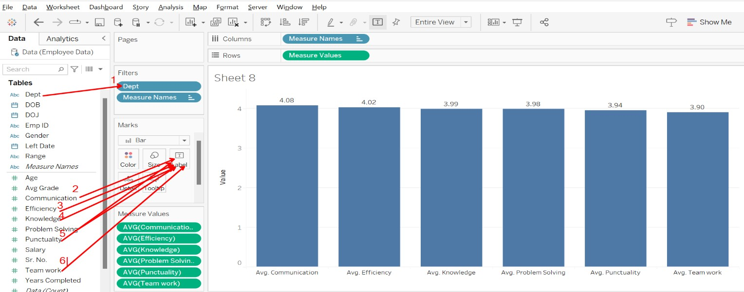***Step 6:*** *Drag the field “Punctuality” into the label (Marks cards)*

**in**

# A screenshot of a computer Description automatically generated with medium confidenceFinal Dashboard

**al Dashboard**